Pitman crm

Business case

WARNING: This document is uncontrolled unless viewed electronically from its original location. Where an uncontrolled document is used it is the responsibility of the person using it to ensure that it is the latest version.
Contents
ABOUT THIS DOCUMENT 3
VERSION CONTROL 3
EXECUTIVE SUMMARY 4
CURRENT BUSINESS CONCERNS 4
PROPOSAL 4
(INSERT PROJECT NAME) BENEFITS 5
SOLUTION OPTIONS 5

ABOUT THIS DOCUMENT

Document purpose | This business case has been prepared to evaluate the implementation of a Customer Relationship Management (CRM) system for Pitman Training. It sets out the current business challenges, potential solutions, benefits, costs, and a recommendation to support decision-making by senior stakeholders.
Intended audience | Pitman Training senior management, project sponsors, and key stakeholders involved in the CRM and website redesign project. It may also be used by Caldwell Foster Advisory and project team members as a reference point during delivery.
Scope | To evaluate the three CRM options (Mailchimp, ActiveCampaign, Salesforce) according to Pitman’s business requirements, budget, and timescale. It covers business concerns, proposed benefits, a comparison of options, and a final recommendation. It does not cover the technical implementation details, training delivery plans, or long-term support arrangements.
Related Documents | https://mailchimp.com  https://mailchimp.com/help/about-mailchimp-pricing-plans  help.activecampaign.com  https://www.emailtooltester.com/en/reviews/activecampaign/pricing/  https://help.activecampaign.com/hc/en-us/articles/14251311251356-Overview-of-ActiveCampaign-plans  https://www.engagebay.com/blog/activecampaign-pricing/  https://salesforce.com  https://www.salesforce.com/sales/pricing/

VERSION CONTROL

Date | Description of Change | Author | Version No.
27/09 | First Draft | Samantha | 0.1

Date | Document | Reviewer / Approver | Version No.

EXECUTIVE SUMMARY
Pitman Training currently manages customer data and marketing campaigns using a combination of manual processes and existing email tools. While this approach has supported basic communication, it lacks the integration, automation, and reporting required to manage a growing contact base (currently ~27,000, projected to exceed 35,000) and a multi-user sales team. Key challenges include limited visibility of sales pipelines, manual lead management, and inefficient campaign tracking.
To address these issues, three CRM solutions were evaluated: Mailchimp, ActiveCampaign, and Salesforce. Each option was compared against Pitman’s requirements for handling large contact volumes, supporting 10 users, delivering automation and dashboards, and providing a scalable pricing model.
- Mailchimp offers strong email marketing and simple automation with built-in landing pages, but its CRM functionality is limited, and its Standard plan caps users at five, requiring a Premium upgrade for Pitman’s needs.
- ActiveCampaign combines powerful marketing automation with an integrated sales pipeline CRM. It scales effectively to 35,000+ contacts, allows multiple users, and provides a good balance of marketing and sales functionality within a manageable cost range.
- Salesforce provides the most robust sales CRM with enterprise-grade dashboards and customization. However, it carries the highest cost of ownership, requires additional setup time, and marketing automation would require further licensing.
Recommendation: ActiveCampaign is recommended as the most suitable CRM for Pitman’s immediate needs. It offers advanced automation, supports the growing contact list and user base, and provides both marketing and sales functionality within the three-month implementation window. This makes it a pragmatic solution for scaling revenue growth while avoiding the high complexity and cost associated with Salesforce.

CURRENT BUSINESS CONCERNS

Ref | Business Concern | Description
1 | Data Fragmentation | Risk of errors, duplicated effort, and lack of a single customer view.
2 | Manual Processes | Current spreadsheets require manual updates; time-consuming and human error prone.
3 | Poor Lead Conversion Tracking | No automated way to follow up with leads or measure conversions.
4 | Limited Customer Insights | No analytics to guide sales/marketing strategy.
5 | Scalability Issues | Growing contact list (35k+) is unsustainable in spreadsheets.

PROPOSAL
The project sponsors will require the BA’s to further explore the above options and create a business case for the benefit of senior stakeholders.
Budget
£97k - this budget will consider Caldwell Foster Advisory’s expenses and any cost of development.
Contacts
Pitman currently has an email list of 27,321 – expected to grow to 35,000 by later this year.
Users
Pitman expect 2 marketing experts, 6 sales staff and 2 managers to use the CRM so 10 users in total.

Pitman CRM BENEFITS
Ref | Feature | Benefit
1 | Automation | Saves time on marketing, lead follow-up, and reporting.
2 | Customer Insights | Dashboards for conversion rates, ROI, and customer behaviour.
3 | Improved Sales Performance | Better pipeline tracking, higher conversion. Therefore, boosts revenue.
4 | Enhanced Communication | Integrated email/SMS + team collaboration.
5 | Scalability & Growth | Supports expansion without data disorganisation

SOLUTION OPTIONS
Option One – Mailchimp
Mailchimp began as an email marketing platform but now incorporates basic CRM functionality that is particularly well suited to organisations who prioritise customer communication over deep sales management. Its features include audience management tools that allow segmentation of contacts, design and scheduling of branded email campaigns, landing pages and sign-up forms for capturing new leads, and performance analytics that measure open rates, click-throughs and conversions. Mailchimp also offers automation sequences such as welcome emails or re-engagement campaigns, helping Pitman maintain regular communication with its student base. For a company like Pitman, which currently relies on spreadsheets, Mailchimp would provide an immediate and user-friendly way to centralise contacts, send targeted campaigns, and connect forms directly to a new website landing page. However, while effective at marketing automation, Mailchimp’s sales pipeline tools are comparatively light, meaning that tracking opportunities from lead to enrolment may remain limited compared to more advanced CRMs.
Key benefits
- Fast to launch: built-in landing pages + forms; easy list growth and nurture flows.
- Audience analytics
- Mature email + automation + AI helpers (subject line/content suggestions).
- Contact-based pricing scales up to 100k contacts on Standard (fits your 35k list).
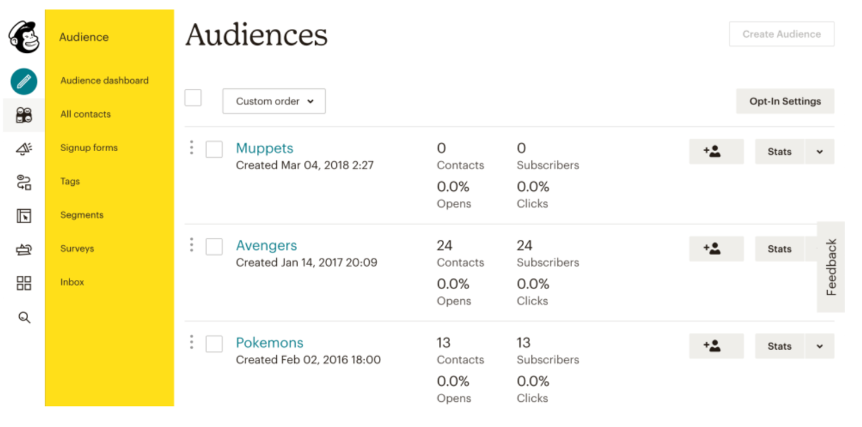
Costs
- Plans scale by contact count; Standard plan supports up to 100k contacts and has send limits (12× contacts). The exact £ cost for 35k is via their calculator; price rises with audience size and currency. Benchmarks: Standard starts ~£15–£20 for 500 contacts; Premium starts ~$350 for 10k+ and rises with contacts. Expect mid–high hundreds £/month at ~35k depending on plan.
Pros
- User-friendly interface and easy setup.
- Affordable entry-level pricing.
- Strong for email marketing campaigns and newsletters.
- Good templates and automation for small teams.
Cons
- Limited sales pipeline and reporting compared to full CRMs.
- Scaling costs increase as contact list grows.
- Weak collaboration tools for larger sales teams.

Where Mailchimp shines / trade-offs
- Best if you’re marketing-first and want landing pages + quick automations.
- Sales pipeline management, bespoke objects, and multi-team workflows are limited vs dedicated CRMs.
Option Two – Active Campaign
ActiveCampaign offers a more balanced approach, combining advanced marketing automation with stronger CRM features. Beyond email campaigns, it provides a visual automation builder that can design complex customer journeys triggered by specific behaviours — for example, a prospective student downloading a course brochure could automatically be assigned to a sales pipeline and receive a sequence of follow-up communications. The platform supports lead scoring, enabling sales staff to prioritise enquiries based on engagement levels, and integrates with website tracking, SMS messaging, and even Facebook custom audience syncing. Its CRM module allows sales teams to create pipelines, assign tasks, and move opportunities through stages, providing more visibility and accountability than Mailchimp. For Pitman, this means that both marketing experts and sales staff could collaborate within a single platform, nurturing leads from first contact right through to enrolment. The system is more complex to learn and certain advanced features are locked behind higher-tier plans, but it provides a strong “all-in-one” solution that scales well with medium-sized organisations.
Key benefits
- Strong visual automations that connect marketing to sales pipelines (lead scoring, site tracking, ecommerce data).
- Native landing pages and forms; robust segmentation and journeys.
- Scales to large lists; multiple plan tiers for marketing and sales.
Costs
- Pricing scales with contacts; plan level unlocks CRM/advanced features. Public calculators don’t show 35k exactly without configuring, but credible benchmarks: $529/month at 35k (historical guide) and $1,169/month at 50k (Enterprise). Real-world 2025 pricing varies by plan and billing (monthly/annual). Expect mid-hundreds to low-thousands per month for 35k contacts depending on tier.
Pros
- Best balance between marketing and CRM functionality.
- Excellent automation and segmentation.
- Scalable with reasonable mid-tier pricing.
- Provides detailed customer journey mapping.
Cons
- Steeper learning curve than Mailchimp.
- Reporting is not as advanced as Salesforce.
- Some advanced features only available on higher plans.

Where AC shines / trade-offs
- Best balance of marketing automation + usable sales pipeline without big-CRM complexity.
- As contacts grow, costs ramp quickly; complex automations need governance.
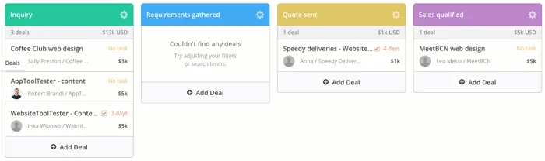

Option Three - Salesforce
Salesforce is the market leader in CRM and offers an enterprise-level system designed for organisations that require deep customisation, advanced analytics, and integration across departments. Its features extend far beyond email marketing: the Sales Cloud supports detailed opportunity management, forecast reporting, and AI-powered insights through Salesforce Einstein; the Marketing Cloud delivers sophisticated multichannel campaigns across email, social, and web; and the Service Cloud provides customer support ticketing and knowledge management. Salesforce’s dashboards are highly configurable, enabling managers to monitor performance across teams in real time, while its AppExchange marketplace offers thousands of add-ons to extend functionality further. For Pitman, Salesforce would provide the most comprehensive platform to future-proof operations, accommodating growth in users and contact volumes well beyond the current 35,000. However, its strengths come with complexity: implementation requires specialist support, staff training is more intensive, and licensing costs are considerably higher than Mailchimp or ActiveCampaign. For a smaller team adopting a CRM for the first time, this may represent both a financial and operational challenge, though it positions Pitman to operate at enterprise scale

Key benefits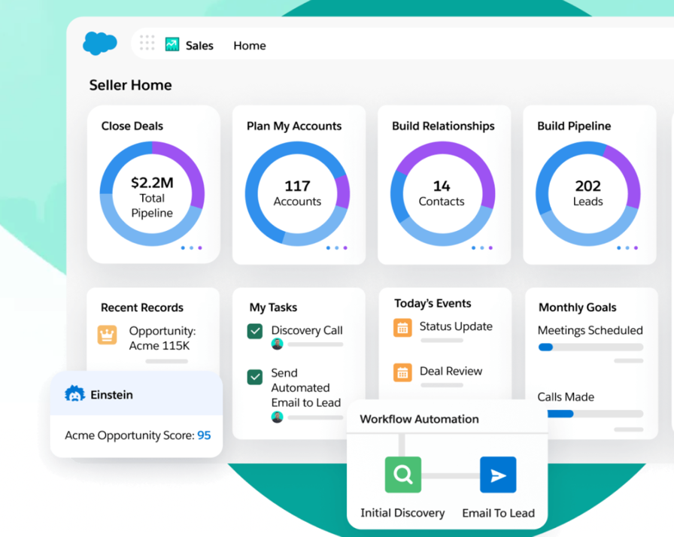
- Robust sales CRM: objects, permissions, custom fields/flows, powerful dashboards; huge ecosystem (AppExchange).
- Excellent executive and operational reporting/dashboards out of the box.
- Scales with your org; long-term platform.
Costs
- Sales Cloud is priced per user/month by edition (Starter from $25/user/mo; higher editions cost more and saw average list price increases in 2025). For 10 users, even Starter is $250+/mo before higher-edition features many teams need.
- Marketing automation (Marketing Cloud/Account Engagement) uses edition/credit-based pricing; quotes vary by use and volume. Expect additional subscription beyond Sales Cloud.
Pros
- Industry leader with comprehensive CRM capabilities.
- Very strong reporting and dashboards.
- Scalable to enterprise-level operations.
- Customisation allows tailoring to Pitman’s future growth.
Cons
- High licensing and implementation cost.
- Requires significant training and ongoing admin.
- May be over-complex for current 10-user team and 35k contacts.

Where Salesforce shines / trade-offs
- Best for complex multi-team sales processes, robust security, custom data model, and enterprise reporting.
- Highest TCO (licenses + implementation + admin). Setup within 3 months is doable but needs focused scope.

CRM Options Comparison
Criteria | Mailchimp | ActiveCampaign | Salesforce
List size fit (35k contacts) | Standard supports up to 100k (12x send cap) | Starter caps at 25k → need Plus or higher | Not contact-metered for Sales Cloud; Marketing Cloud editions sized by usage
Users (10 required) | Standard includes 5 seats; Premium for >5 | Plus: 1, Pro: 3, Enterprise: 5 (can buy more) | Per-user licenses; 10 seats required
Pricing model | By contacts (plan-based) | By contacts (plan-based) | Per user/month + add-ons
Indicative cost (35k/10 users) | Mid–high £ hundreds/mo (Standard); Premium higher | Mid £ hundreds–low £ thousands/mo | $250–$3,500+/mo depending on edition + add-ons
Landing pages & forms | Built-in | Built-in, tied to automations | Via Experience Cloud or Marketing Cloud
Automation depth | Strong (marketing-led) | Very strong; journeys tie into CRM deals | Powerful workflows; marketing automation via add-on
Dashboards & reporting | Good marketing analytics | Good marketing + pipeline views | Enterprise-grade reporting
TCO (setup & running) | Lowest; watch price creep & seat limits | Moderate; scales with contacts + seats | Highest; licenses + implementation + admin
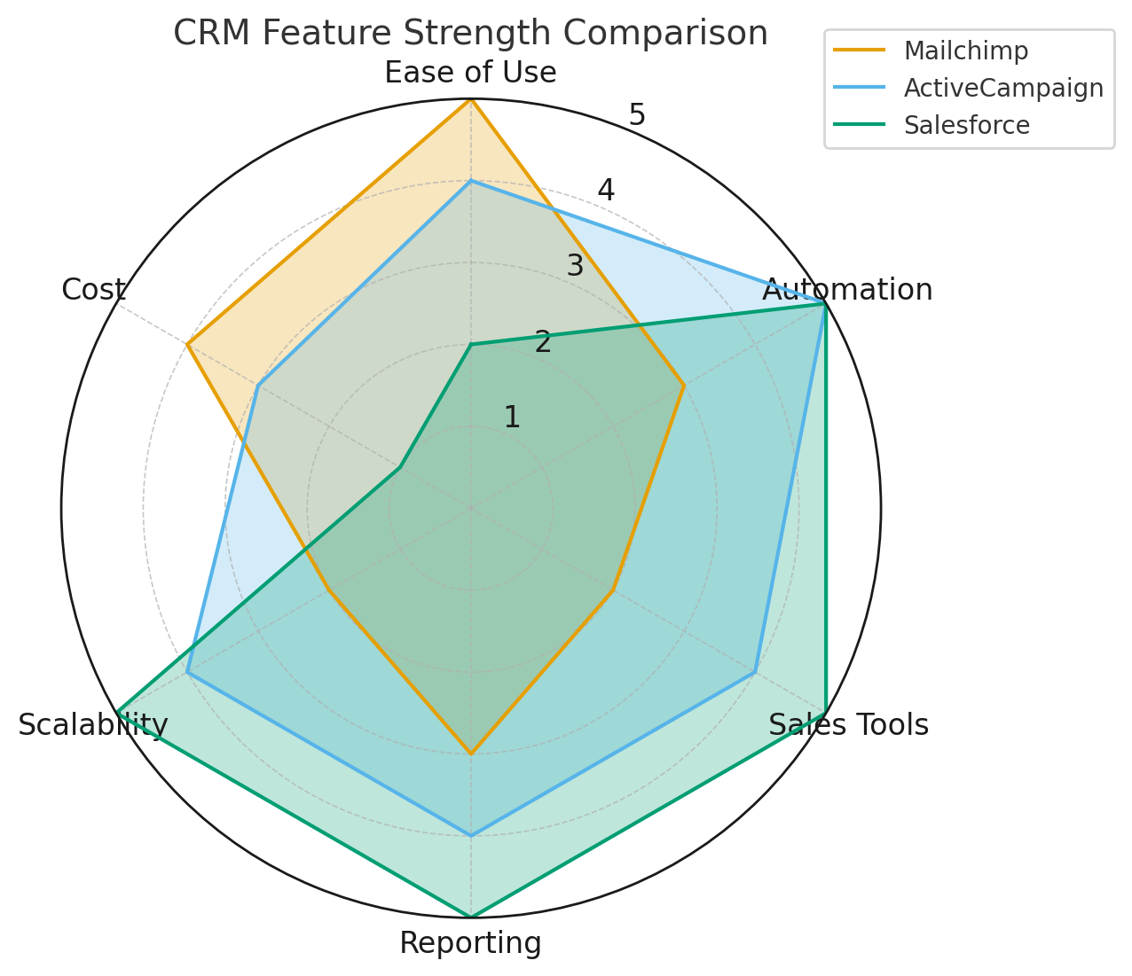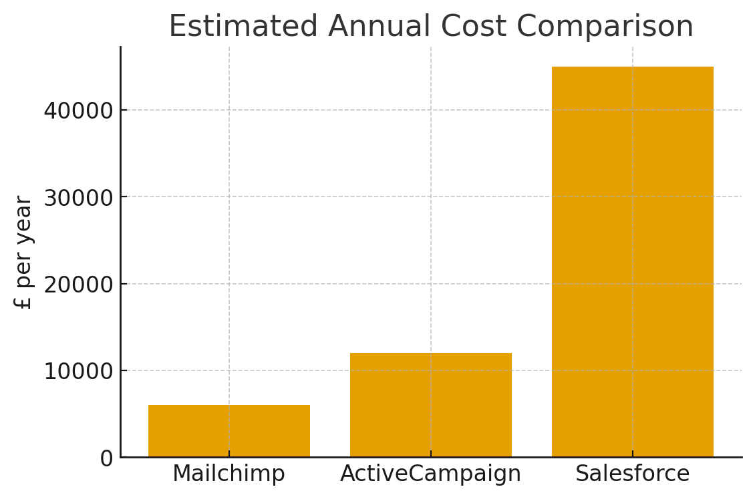
I recommend Pitman to use option 2 because if they want both serious marketing automation and a workable sales pipeline without enterprise overhead, ActiveCampaign is the pragmatic pick for the next 6–12 months; it fits the 3-month window, aligns with your list size, and lets you mature processes before considering Salesforce. Mailchimp is the simplest path if you go marketing-only; Salesforce is the long-term platform if you’re ready for a bigger investment and governance.

